**2022 Brixton Capital**

**Climate Assessment Results**

Survey and Report Prepared by:

Civility Partners, Inc

Contact: Catherine Mattice, MA, SHRM-SCP, CEO

[www.CivilityPartners.com](http://www.civilitypartners.com)

[Info@CivilityPartners.com](mailto:Info@CivilityPartners.com)

## 

Table of Contents

Summary 2

Statistical Analysis 2

Themes from Open-Ended Feedback 2

Our Recommendations for Improvement 3

Quantitative Data 4

Strengths 4

Opportunities for Improvement 5

Motivations 7

Qualitative Data 8

Strengths 8

Opportunities for Improvement 10

## Summary

A total of 36 people submitted survey responses.

The results show that employees get along well with one another and feel that the organization provides good quality service to clients. Responses in both the open-ended comments and motivations category indicated that employees truly value their positive relationships with one another.

The survey also indicated that there is room for improvement in top-down communication, overall organizational communication, performance management (e.g. conversations about growth), and training and onboarding. In addition, there seems to be dissatisfaction with the current benefits and total compensation package, with base pay and promotion opportunities scoring the lowest in that category.

Lastly, 26% of your workforce would not recommend Brixton as a good place to work and thus culture change is necessary to address this sentiment.

## Statistical Analysis

Due to the limited sample size and missing gender/tenure distinctions for some submissions, there isn't any statistically significant difference between 'Male/Female' and 'working less than 5 years/ 5+ years' for all questions.

## 

## Themes from Open-Ended Feedback

**Strengths**

* Positive relationships
* Positive culture
* Connection to the work/organization itself
* Benefits are appreciated

**Opportunities for improvement**

* Lack of work/life balance or flexibility
* More transparency and open communication needed
* Employees want to be trusted
* Compensation is unsatisfactory
* Lack of advancement opportunities
* Lack of clear organizational direction
* Need for training
* Experience depends on certain factors (e.g. department, personality)
* Culture

## 

## Our Recommendations for Improvement

First and foremost, we recommend **distributing a summary of these survey results to your workforce with the message that you will take immediate action to address the problem areas.**

We also suggest that **messaging include at least three items that are high impact and also "low hanging fruit”** - actions you pledge to take that can be implemented quickly, and also facilitate a feeling of movement towards change. Examples we’ve seen in the past include:

* A promise (and follow through) to hold quarterly town hall meetings to share updates and answer questions
* “Coffee with the CEO” programs to help build relationships and transparency
* Implementing a monthly newsletter to keep employees informed of important changes, wins, etc.

From there, we recommend the following immediate actions:

1. If you haven’t already, **get clear on the organization’s goals for the future - the vision, mission, and company goals for the next year, next three years and next ten. Then clearly communicate that to your workforce.** We can absolutely help you with this process if you need.
2. A key recommendation that will address many issues is **revamping your performance management system. It will increase communication, trust, engagement, loyalty, relationships, and more.** A comprehensive program includes ongoing feedback, defining growth opportunities, career mapping, clarity on skills needed to move through the map (competencies), manager/supervisor training on coaching, recognition programs, and quarterly performance check-ins. We also suggest:
   1. **The performance management system is tied to the organization’s year 1 and year 3 goals.**
   2. **Managers and supervisors receive training on collaborative conversations, coaching, and employee recognition.**
3. **Implement a rewards and recognition system** that confirms for your workforce that they are acknowledged and valued for the work they do. The program should include peer recognition and recognition from managers.
4. **Create a system for more clear and transparent communication from leadership.** Employees are seeking more transparency from leadership around policies, growth, company direction and more. Creating a more clear system for top down communication will help increase employee engagement and buy-in to organizational systems. In addition, this will help employees feel they understand where the organization is heading.
5. **Update the onboarding process and training program for new hires.** According to the survey, many do not feel they are well-equipped to do their job after the training process is complete. We’d recommend interviewing the new hires to understand where the opportunities for improvement are in this area in order to revamp this program. In addition, having a structured onboarding program can help employees connect better to the organization and inspire them to do their best work.
6. **Execute a management training program that includes such topics as proactively fostering a positive work environment, building trust, delegation, leading their teams through change, and more.** It’s vital that managers have the necessary skills to foster a positive, collaborative environment. Often we see managers move into management roles because they know how to do the job well, but they are not equipped with tools to manage performance, set expectations, and address negative behavior.
7. **Create and execute a strategic plan to address survey results using an internal action team.** We can help you create an action team and facilitate creation of the strategic plan to address the survey results and ultimately improve culture. The action team could, for example, develop and implement ideas to improve internal communication processes and transparency, revamp your training program, hone in on a clear vision and mission, etc. This process also includes **ongoing partnership with the leadership team** to assist in messaging and moving forward.

## Quantitative Data

This section includes a breakdown of strengths and opportunities in the quantitative data (statements rated on a Likert scale). These are formatted in bullet points in order to streamline the report. A full database of the charts can be found [here](https://drive.google.com/file/d/180QogsOA_o20qxXR4EqF8sjq88A8FOvw/view?usp=sharing).

#### **Strengths**

All of the questions below received a 90% or higher positive response (i.e. respondents answered somewhat agree/strongly agree or very satisfied/satisfied) **The percent is the total positive response**:

* It is clear to me how my role helps this organization achieve its goals. (94%)
* The overall quality of this organization’s services is good or better. (92%)
* This organization cultivates an environment where people of many backgrounds are welcomed and valued. (92%)
* My team gets along with each other. (91%)

#### **Opportunities for Improvement**

All of the questions below received a 25% or higher negative response (i.e. respondents answered somewhat disagree/strongly disagree or somewhat dissatisfied/very dissatisfied). **The percent is the total negative response.**

*Organizational Culture*

* I have a clear understanding of my organization’s vision for the future. (50%)
* This organization inspires me to do my best work everyday. (39%)
* There is an atmosphere of trust within the organization. (36%)
* The current culture in your organization. (32%)
* Would you recommend this organization as a good place to work? (26%)

*Organizational Systems*

* We quickly adapt to challenging or crisis situations. (36%)
* The overall organizational structure (e.g., number of employees in your team, hierarchy, job positions, etc). (35%)
* I have the right amount of flexibility in my work schedule. (33%)
* I have the right amount of work-life balance. (28%)

*Leadership*

* How the leadership team manages the overall efficiency of the organization. (68%)
* I have confidence in the leadership team. (39%)
* Your relationship with the CEO. (32%)
* I trust the decisions the leadership team makes, even if I don’t understand “the why” behind them. (28%)

*Training/Onboarding*

* I am able to implement what I learn from job training. (52%)
* The topics covered in the job training are useful. (52%)
* The amount of job training received is helpful. (48%)
* The onboarding process was helpful to me (9 responses, 33%)

*Performance management*

* The possibilities for career progression in this organization are clear to me. (74%)
* The process to receive recognition or praise seems fair. (53%)
* My supervisor and I collaborate on my professional growth. (50%)
* The process for evaluating job performance is clear. (44%)
* My supervisor provides me with actionable suggestions on what I can do to improve. (44%)
* I receive recognition or praise for doing good work often enough to suit me. (44%)

*Overall communication*

* I receive information in a timely manner to do my job. (38%)
* The departments communicate well with each other. (35%)
* I have a say in decisions that affect my job. (35%)
* The existing relationships between teams or departments work well. (32%)
* My department’s goals are clear to me. (29%)

*Top down communication*

* How the leadership team communicates about how to get a bonus or promotion. (74%)
* How the leadership communicates about upcoming changes in the organization. (62%)
* How the leadership team communicates about company vision and goals. (53%)
* How the leadership team communicates about profits and/or financial standing. (50%)
* How the leadership team responds to complaints or problems brought to their attention. (47%)
* How the leadership team communicates company policies. (44%)
* How the leadership team communicates about the company’s successes and failures. (38%)

*Benefits/Compensation*

* Promotion opportunities. (74%)
* Base pay. (62%)
* Bonus. (47%)
* Total compensation package. (47%)

#### **Motivations**

**Top five reasons an employee would look for a new job outside of the organization include:**

1. My total compensation (62%)
2. Career advancement opportunities (56%)
3. Work/life balance (41%)
4. Opportunity for professional growth (30%)
5. Transparent communication processes (30%)

One person wrote, “Hybrid WFH opportunities”

**Top five reasons employees continue to work at the organization include:**

1. My peers/coworkers (74%)
2. Meaningful work (38%)
3. Culture (32%)
4. My supervisor/manager (29%)
5. Opportunity for professional growth (26%)

One person wrote, “I’m incredibly fortunate to have a boss who instills trust in me to successfully do my job and coworkers that all support each other.”

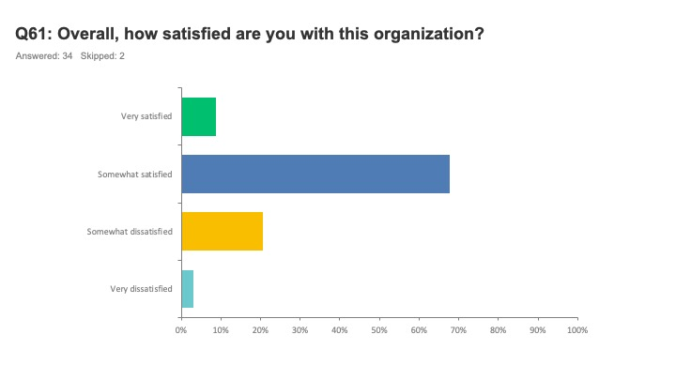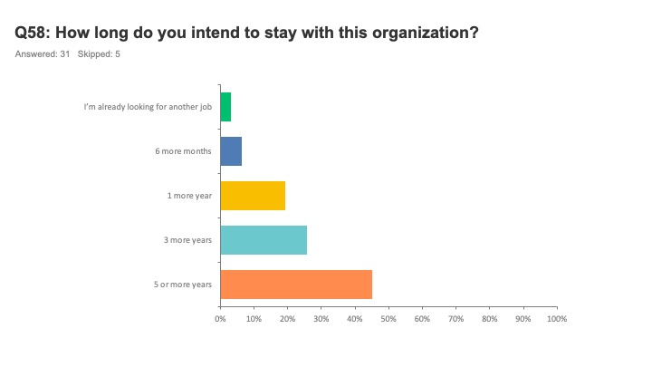

## Qualitative Data

#### **STRENGTHS**

**Positive Relationships**

* Love the people.
* The people are great.
* Great cooperative and fun culture.
* Most of us are respectful of one another.
* Everyone is nice and respectful to team members.
* Positive environment and great people to work with
* Overall, the people at Brixton are great and I am challenged in my work.
* The people and relationships.
* I work with an amazing group of people. Talented and hard working.
* Overall how people as a whole get along and seem to enjoy participating in internal as well as external events.
* I like how driven everyone at the company is and we are all here to help each other out. It makes work easier when everyone has each other's back.
* Culture is nice in that it's private and most employees get on and seem to be a good fit socially.
* Everyone has a can-do attitude and great open-door policy with leadership. Egos are put aside for the greater good of the company
* I feel Brixton's best asset is its people. We have a diverse group, but mostly everyone works well together and enjoys each other's collaboration.
* We have caring managers and an energetic group of talented professionals who work well overall with each other and are fun to be around. Most share similar values, particularly in work and life quality.
* The employees really care about each other.
* Whenever I'm asked why I enjoy working at Brixton, my answer is always, the People.
* Most peers/coworkers are friendly, smart and to me it has a relatively nice culture being a small private company.
* I'm glad we take the time during the interview process to really screen candidates as it only takes one or two bad apples to have a negative impact.

**Positive Culture**

* Atmosphere is overall good.
* Positive environment "OVERALL"
* I enjoy the current culture.
* Culture, location, company values.
* The openness to new and creative ideas;
* Culture among the troops on the ground is great.
* Good culture and people. Everyone works hard.
* I like the fast-paced work but casual environment.
* The company has a strong, inclusive culture.
* I feel our office culture is better than the average office.
* Open door policy, people, location, good work facility and fun productive working atmosphere.
* I feel it has a good mix of professionalism (very talented, smart, and motivated group of coworkers) but also with the right amount of fun-loving, joking, and friendliness. I think it's important to have this balance.
* There is collaboration, some social events, and the best measurement of a good office environment is the average tenure of its employees. Although we have several new faces, due to expansion of departments, for the most part, there are several long-term employees.

**Connection To The Work/Organization Itself**

* Valued work
* Good leadership, interesting work
* Very creative and dynamic company.
* Good place to work with a great industry reputation
* The people and culture as well as the diversity of asset/investment types that we work with (provides for good learning opportunities / professional growth.)

**Benefits Are Appreciated**

* Office
* The view from the office isn't bad either!
* I do like to come into an office (and appreciate the location.)
* Our gym is a great way to blow off steam and bond with team members.
* I really appreciate the Flex Friday schedule! That has been a great additive in work life balance
* The company offers different ways to improve physical and mental health, additional amenities and facilities in the gym would likely improve the experience.

#### **OPPORTUNITIES FOR IMPROVEMENT**

**Lack Of Work/Life Balance Or Flexibility**

* Work life Balance, with minimum 3 weeks' vacation and 12 paid holidays.
* Ideal culture: flexibility schedule & work/life balance.
* More flexibility for wfh for appointments/day care problems, and not being frowned upon if requested.
* An ideal company culture is providing a flexible work/life balance environment, and managing work expectations.
* Work life balance is a real issue in that senior management expects everyone in the office (for most people) 5 days a week. I believe it will be difficult to attract real talent with a very inflexible schedule.
* My only complaint would be that I'm not sure that everyone in the executive team shares the same appreciation for the balance, or understands the importance of being able to have fun at work, in addition to just producing top work performance
* I do wish there would be an option (perhaps 1x every month, that employees could opt to work from home, to avoid workplace interruptions, and provide a day to catch up on tasks or tackle time-sensitive projects.

**More Transparency and Open Communication Needed**

* No transparency in communication
* Ideal company culture would be transparency of our roles, responsibilities, company policies that include each department if different.
* Ideal culture: Transparency of company policies/procedures throughout every department.
* An ideal company culture is keeping lines of communication open at all levels.
* Opportunities to collaborate with all levels in the organization and understand how having processes or the lack thereof can benefit / detriment a company.
* Difficult to answer - for some, this environment may work, but for others who are seeking more transparency, effective communication, defined vision then I would answer no.

**Employees Want To Be Trusted**

* Ideal culture: Trust
* Ultimately the team is not trusted by leadership.
* Less micromanagement by management.
* Flexibility and trust from upper management.
* An ideal company culture: better understanding of teamwork by upper management. Would like the CEO to have more faith in the team and employees and to be less hands on.
* There has to be more trust amongst senior leadership at the very top that people can be productive and continue to communicate while working (from time to time) in other locations.

**Compensation Is Unsatisfactory**

* An ideal company would reward consistent achievement.
* My compensation is lower than average for my peer group in similar positions.
* Base salary is average but not equal to industry standard for experience and workload.
* Loyalty and staying with the company for a long period of time allows salary compression to take place.
* In my position, I am underpaid when compared to market standards. Brixton should consider inflation and the San Diego cost of living when looking at salaries.
* There's an approx. 7% salary gap between new hires and current employees. The loyal employees who are NOT leaving are getting the short end of the stick.
* More forward-thinking companies should re-evaluate salaries of current employees and be willing to renegotiate compensation (dollars or benefits) or offer “staying” bonuses.
* I feel that given my level of contribution to the overall organization I am not compensated to a level that fully acknowledges my ability to generate revenue for the company, my contribution to recruiting talent for the company or my contribution to the culture of the organization.

**Lack Of Advancement Opportunities**

* There is no clear career path.
* Zero promotion opportunity has been communicated.
* Career advancement is limited with a top heavy hierarchy.
* Top heavy organization. Family dynamic.
* Would like a better understanding of promotion opportunities.
* I've seen a few people promoted in the past; however, it appears most opportunities are sent externally first and not mentioned internally.
* Good for someone earlier in their career for development and mid-career for benefits. May not be ideal for someone looking to advance into higher positions with higher pay.
* I have been with my leader for a long time and feel that I don't get feedback or recognition that I deserve.
* Promotion opportunities appear to be limited and can be disheartening when leadership starts interviewing external candidates before the team knows there is a job posting for a specific role.

**Lack Of Clear Organizational Direction**

* I feel that there is no clear direction for the company as a whole.
* No clear vision. Takes too long to get deals approved.
* The vision for the company is not clear. We are very unfocused.
* It appears that we are quick to hire and slow to make any productive changes in areas where change is desperately needed.
* Better organization of retail Aquisition effort, legal and development teams. Read Extreme Ownership, By Jocko Willink (Chapter 8 and 12)
* Current culture has an opportunity to change; adaptation is slow and there are no written procedures.

**Need For Training**

* Upper management could use some training and coaching.
* There is a great platform to grow this company to something large and successful, but I do not believe the leadership is in place to do so.
* Ideal company culture has ongoing training (for continuous change and not reacting). Training reinforces and confirms changes so that there is no anxiety.The training should inspire change, and the results can be transformative.
* Training shows a clear path to the end result, and written procedures help confirm the direction with step-by- step manuals (which can be reviewed later if the training schedule is not convenient). Training may need to be done by an outsider and attendees should not have both management and staff so that there is safety to speak out freely.

**Experience Depends on Certain Factors**

* No work/life balance depending on the dept.
* 14 depends on the department.
* Depends on what role/department within the company.
* My answer would depend on the specific position and the person I was recommending the job
* Overall, the company can be a great place to work but only for those with the right outlook (flexible, open to change and able to work independently).
* The culture and nature of work demands a very specific personality-type-most people would not thrive or enjoy the culture, pace of work, stress or chaotic nature of the firm. Therefore, I would only recommend it to a limited subset of people.

**Culture**

* Place is like high school
* Very unique from my past experiences.
* Family office dynamic adds an additional layer of unnecessary stress.
* Our culture has changed over the last few years. Both the change in leadership and Covid have impacted the way our employees interact.